**ALM Integration**

[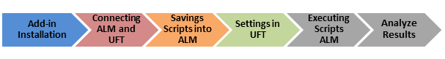](http://cdn.guru99.com/images/hpalm/071114_0934_Howtointegr1.png)

**1. Addin Installation**

1. To connect ALM with uft we need to install addin of ALM from tools
2. If already installed, then we will just rcvd

[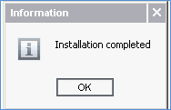](http://cdn.guru99.com/images/hpalm/071114_0934_Howtointegr6.png)

1. Then from uft ALM , ALM connection

1. Enter the ALM server URL
2. Enter the UserName
3. Enter the Password and click 'Connect'

**

1. Select Domain
2. Select the project
3. Click 'Login'

**3. Open or create Script**

Select file open /or new

1. Click alm test plan
2. Click functional
3. Click automation
4. Select the script/for new create and save here

**4. Associates Library create /upload**

**From Resources if we need to create function library and shared OR and Test data**

1. Click Resources, name it and click ok
2. Then upload from Resources Viewer FL and SOR and Test data one by one

**5. Executing Test Script**

1. For Execution we need to create automation test suite under Test Lab
2. From the test suite we need to select the test Script
3. If more than one then we can run all

**6. Analyze Result**

1. The test also generates a text result file which can accessed from the attachments section. To access the file we need to select RUN ID

